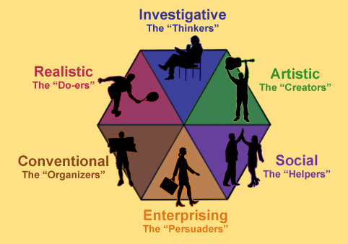
Planning 10
Holland’s Hexagon Questions
Name: ___________________
1.What is your acronym?_____________ What are your top THREE categories? Type them in the chart below.
2. Click on the list of occupations for your acronym. http://www.onetonline.org/explore/interests/Social/Enterprising/Realistic/
Click on an occupation from each category and fill in the chart below. Choose one description that you would like to do, you can do already or that you need to learn.
Categories

Occupation

Tasks

Technology Skills

Knowledge

Skills

Abilities

Work Activities

Detailed Work Activities

Interests

Work Styles

Work Values

- What were TWO benefits for you of doing this personality quiz? ____________________________________________________________________________________________________________________________________________________________

- Was this quiz accurate in synthesizing your interests? _____Why or why not?
____________________________________________________________________________________________________________________________________________________________
- What are TWO ways a quiz like this can be misleading or inaccurate? ____________________________________________________________________________________________________________________________________________________________
- From the occupations suggested, which one interests you? ______________________________
- What recommended occupation surprised you? _______________________________________
- Is there an occupation NOT on the list that interests you or you feel matches your interests? ______________________________________________________________________________

